# FINAL YEAR PROJECT 1

**SAT (8:30-11-30)**

# INSTRUCTOR:

DR.AARIJ MAHMOOD HUSSAAN

# SUPERVISOR:

Ma’am Sana Irshad

# GROUP MEMBERS:

* UROOJ TARIQ (10619)
* MAIDAH FAROOQUI (13711)
* MUHAMMAD AHSAN SHAHZAD (13719)
* DOHA BASIT (13899)

**SMART QUIZCAST**

# DESCRIPTION:

Smart Quiz cast is a web-based project that aims to revolutionize student assistance through engaging lectures and interactive quizzes.

With Smart Quiz cast, students can dive into a world of educational content while having their knowledge tested along the way. Each lecture video is enhanced with pop-up quizzes that appear at relevant moments, allowing students to apply what they've learned and reinforce their understanding of the topic. One of the key features of Smart Quiz cast is the student progress section. Here, students can track their quiz remarks and scores, enabling them to monitor their growth and identify areas for improvement. To access these features, students can create their own login ID, providing them with a personalized learning experience. They can easily navigate through the website, exploring different courses and classes through a dedicated tab. Whether they're interested in math, science, literature, or any other subject, Smart Quiz cast has a wide range of offerings to cater to diverse interests.

# BENEFIT:

* **Better Understanding**: Quizzes during videos help students see what they’ve learned and what they need to review.
* **Immediate Feedback**: Instant feedback helps students correct mistakes and reinforce learning.
* **Personalized Learning**: Students can track their progress and focus on areas needing improvement.
* **Motivation**: Tracking progress keeps students motivated and engaged.
* **Flexible Learning**: Content is accessible anytime, allowing students to learn at their own pace.
* **Time Management**: Quizzes and progress tracking help students manage their study time more effectively.

Top of Form

Bottom of Form

# REQUIREMENTS

# FUNCTIONAL REQUIREMENTS:

## AI- BASED POP-UP QUIZZES AND REMARKS:

AI-based quizzes integrated through chatgpt using its API into lecture videos and remarks related to the quiz attempted.

* **AUTHENTICATION**:

User authentication with login ID and password.

## STUDENT RECORD

Keeping record of student’s information along with quiz marks and remarks.

## REQUEST HELP FEATURE:

Allowing users to ask questions from chatbot.

## SEARCH AND FILTER:

The website will provide an option to search for specific lecture videos/notes or filter them based on subject.

## LECTURE NOTES:

Allowing user to access lecture notes or accompanying materials for each video.

## RATING SUBMISSION:

Users have the option to submit ratings and add comment as per the experience, after visiting a website.

## NOTIFICATIONS:

Allowing website to generate notifications or alert through email for new lecture uploads, upcoming quizzes, or activity.

# NON-FUNCTIONAL REQUIREMENTS:

* **Real-time Responsiveness:**

Ensure real-time updates and notifications are delivered promptly to users, enhancing communication and engagement with new content and announcements.

* **Easy to use/ Use friendly**

The website should have a user-friendly interface that makes it easy for students to navigate between lecture videos, subtopics, and quizzes.

* **Performance:**

The website's minimum response time should be 5 seconds. The website should run smoothly without any lag or delays, providing a seamless learning experience for students.

* **Smooth Multi-User Experience:**

Ensure the website can smoothly accommodate multiple students simultaneously for uninterrupted learning.

**REQUIRED DIAGRAM**

These documents collectively guide the development and implementation process, ensuring clarity, functionality, and alignment with project objectives.

To ensure the smooth operation of this project, we have created essential diagram documents including,

* Use case diagram outlining system interactions
* Use case narratives detailing specific user actions,
* An Entity-Relationship Diagram (ERD) illustrating database structure,
* A state diagram depicting system states and transitions,
* Prototype demonstrating the user interface and functionality.

**USE CASE DIAGRAM**

W have created use case diagram and narratives to clearly define and document the interactions between users (students, instructors, admins) and the system, ensuring that all functionalities and user roles are understood and properly implemented.

•

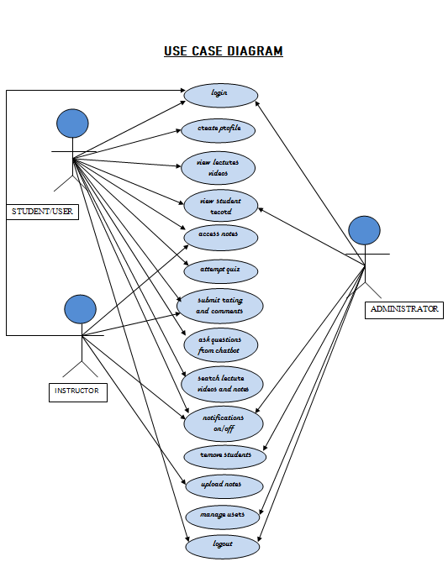

**USE CASE NARRATIONS**

|  |  |  |
| --- | --- | --- |
| **Use Case 1** | Login | |
| **Actors Involved:** | Administrator, Student, Instructor | |
| **Brief Description** | This use case describes the steps taken by the user to log in the system. | |
| **Pre-Conditions** | The user must be registered to use the website. | |
| **Post-Conditions** | The user gains access to the system. | |
| **Normal Flow of Events:** | **Actor Action** | **System Response** |
| * User enters username and password to log in. * User gains access to the system. | * System verifies login credentials and grants access to the website. . |

|  |  |  |
| --- | --- | --- |
| **Use Case 2** | Create profile | |
| **Actors Involved:** | Student | |
| **Brief Description** | This use case describes the steps taken to create a mentor profile. | |
| **Pre-Conditions** | The user must be logged in to the system. | |
| **Post-Conditions** | The created mentor profile is stored into the database. | |
| **Normal Flow of Events:** | **Actor Action** | **System Response** |
| * Select the create profile option. * Enter and save profile details. | * Display profile form. * Store profile details. |

|  |  |  |
| --- | --- | --- |
| **Use Case 3** | View lecture videos | |
| **Actors Involved:** | Student | |
| **Brief Description** | This use case describes the steps taken to view lecture videos. | |
| **Pre-Conditions** | The student must be logged in to the system. | |
| **Post-Conditions** | The student can attempt the quiz. | |
| **Normal Flow of Events:** | **Actor Action** | **System Response** |
| * Enters a relevant lecture topic into the search bar. * Select the lecture video. | * Display the selected lecture video. |

|  |  |  |
| --- | --- | --- |
| **Use Case 4** | View student record | |
| **Actors Involved:** | Administrator, Student | |
| **Brief Description** | This use case describes the steps taken to view student record. | |
| **Pre-Conditions** | The administrator and student must be logged in to the system  The student must be attempt quiz and view lectures. | |
| **Post-Conditions** | Student records are displayed. | |
| **Normal Flow of Events:** | **Actor Action** | **System Response** |
| * Select the student record button. | * Display student record. |

|  |  |  |
| --- | --- | --- |
| **Use Case 5** | Access notes | |
| **Actors Involved:** | Student, Instructor | |
| **Brief Description** | This use case describes the steps taken to access notes. | |
| **Pre-Conditions** | The student must be logged in to the system.  The student must use the search bar to find the lecture notes. | |
| **Post-Conditions** | Lecture notes are displayed | |
| **Normal Flow of Events:** | **Actor Action** | **System Response** |
| * Uses the search bar to find notes. | * Display lecture notes. |

|  |  |  |
| --- | --- | --- |
| **Use Case 6** | Attempt quiz | |
| **Actors Involved:** | Student | |
| **Brief Description** | This use case describes the steps taken to attempt quiz. | |
| **Pre-Conditions** | The student must view the lecture videos. | |
| **Post-Conditions** | Student can view remarks and marks of attempted quiz. | |
| **Normal Flow of Events:** | **Actor Action** | **System Response** |
| * Student logged in and view lecture videos. | * Display quiz after lecture video. * Display marks and remarks of the attempted quiz. |

|  |  |  |
| --- | --- | --- |
| **Use Case 7** | Submit Ratings and Comments | |
| **Actors Involved:** | Student, Instructor | |
| **Brief Description** | This use case describes the steps taken to submit ratings and comment. | |
| **Pre-Conditions** | The student and Instructor must be logged in to the website. | |
| **Post-Conditions** | Website shows the updated rating. | |
| **Normal Flow of Events:** | **Actor Action** | **System Response** |
| * User enters username and password to log in. * User submit their ratings and comment. | * Display the updated ratings and comments. |

|  |  |  |
| --- | --- | --- |
| **Use Case 8** | Ask questions from Chatbot. | |
| **Actors Involved:** | Student | |
| **Brief Description** | This use case describes the steps taken to ask a questions from chatbot. | |
| **Pre-Conditions** | The student must have the login credentials. | |
| **Post-Conditions** | The system displays relevant answers to the questions asked by the student | |
| **Normal Flow of Events:** | **Actor Action** | **System Response** |
| * User enters username and password to log in. * Student ask the questions from chatbot | * Access to the system upon successful login. * Displayed relevant answers. |

|  |  |  |
| --- | --- | --- |
| **Use Case 9** | Search lecture videos and notes | |
| **Actors Involved:** | Student | |
| **Brief Description** | This use case describes the steps taken to search lecture videos and notes. | |
| **Pre-Conditions** | The students must be logged in to the system. | |
| **Post-Conditions** | The system displays relevant lecture videos and notes. | |
| **Normal Flow of Events:** | **Actor Action** | **System Response** |
| * Enters a relevant lecture into the search bar. | * Displays relevant lecture videos and notes based on the search |

|  |  |  |
| --- | --- | --- |
| **Use Case 10** | Notification on/off | |
| **Actors Involved:** | Student, Administrator, Instructor | |
| **Brief Description** | This use case describes the steps taken to on/off the notifications. | |
| **Pre-Conditions** | The student must be logged in to the website. | |
| **Post-Conditions** | The notification settings are successfully updated as per the user's preference. | |
| **Normal Flow of Events:** | **Actor Action** | **System Response** |
| * Adjusts the notification settings to turn notifications on or off. | * Adjusts the notification settings to turn notifications on or off. |

|  |  |  |
| --- | --- | --- |
| **Use Case 11** | Remove students | |
| **Actors Involved:** | Administrator | |
| **Brief Description** | This use case describes the steps taken to remove the students. | |
| **Pre-Conditions** | The Administrator must be logged in to the website. | |
| **Post-Conditions** | The updated list of students is displayed. | |
| **Normal Flow of Events:** | **Actor Action** | **System Response** |
| * Select the Student profile from list. * Select the remove student button. | * Display the selected student profile. * Display the updated list. |

|  |  |  |
| --- | --- | --- |
| **Use Case 12** | Upload notes | |
| **Actors Involved:** | Instructor | |
| **Brief Description** | This use case describes the steps taken to upload lecture notes. | |
| **Pre-Conditions** | The Instructor must be logged in to the website. | |
| **Post-Conditions** | The updated lecture notes list is displayed. | |
| **Normal Flow of Events:** | **Actor Action** | **System Response** |
| * Logs in to the website and updates the lecture notes list. * Select the upload notes button. | * Display the updated notes list. |

|  |  |  |
| --- | --- | --- |
| **Use Case 13** | Manage user | |
| **Actors Involved:** | Administrator | |
| **Brief Description** | This use case describes the steps taken to manage a user. | |
| **Pre-Conditions** | The administrator must be logged in to the system .  The user details must be saved into the database. | |
| **Post-Conditions** | The modified user details are stored into the database | |
| **Normal Flow of Events:** | **Actor Action** | **System Response** |
| * Select the edit user button. * Enter and save changes user details. | * Display edit user form. * Store modified user details. |

|  |  |  |
| --- | --- | --- |
| **Use Case 14** | Logout | |
| **Actors Involved:** | Administrator, Student, Instructor | |
| **Brief Description** | This use case describes the steps taken by the user to log out of the system. | |
| **Pre-Conditions** | The user must be registered and logged in to the website. | |
| **Post-Conditions** | The user securely logs out of the system. | |
| **Normal Flow of Events:** | **Actor Action** | **System Response** |
| * User logs out. | * System securely logs out the user from the website. |

Bottom of Form

**USE CASE DESCRIPTION**

**ACTORS:**

List of actors who will interact with the system.

* Admin
* Student/User
* Instructor

**ADMINISTRATOR:**

* Login.
* Remove students/users.
* View Student Record.
* Notification ON/OFF.
* Manage users.
* logout.

**STUDENT/USER:**

* Register itself.
* Create profile.
* View profile
* Login.
* View lecture videos.
* Access notes
* Attempt Quiz.
* Submit ratings and comment.
* Search lecture videos and notes.
* Ask questions from chatbot.
* Notification ON/OFF.
* View Student Record.
* Logout

**INSTRUCTOR:**

* Login.
* Upload lectures and notes.
* View Student Record.
* Submit ratings and comment.
* Notification ON/OFF.
* logout.

**ENTITY RELATIONSHIP DIAGRAM**

Created ERD To design and visualize the database structure, ensuring efficient data storage, relationships between entities (such as students, courses, quizzes), and maintaining data integrity.

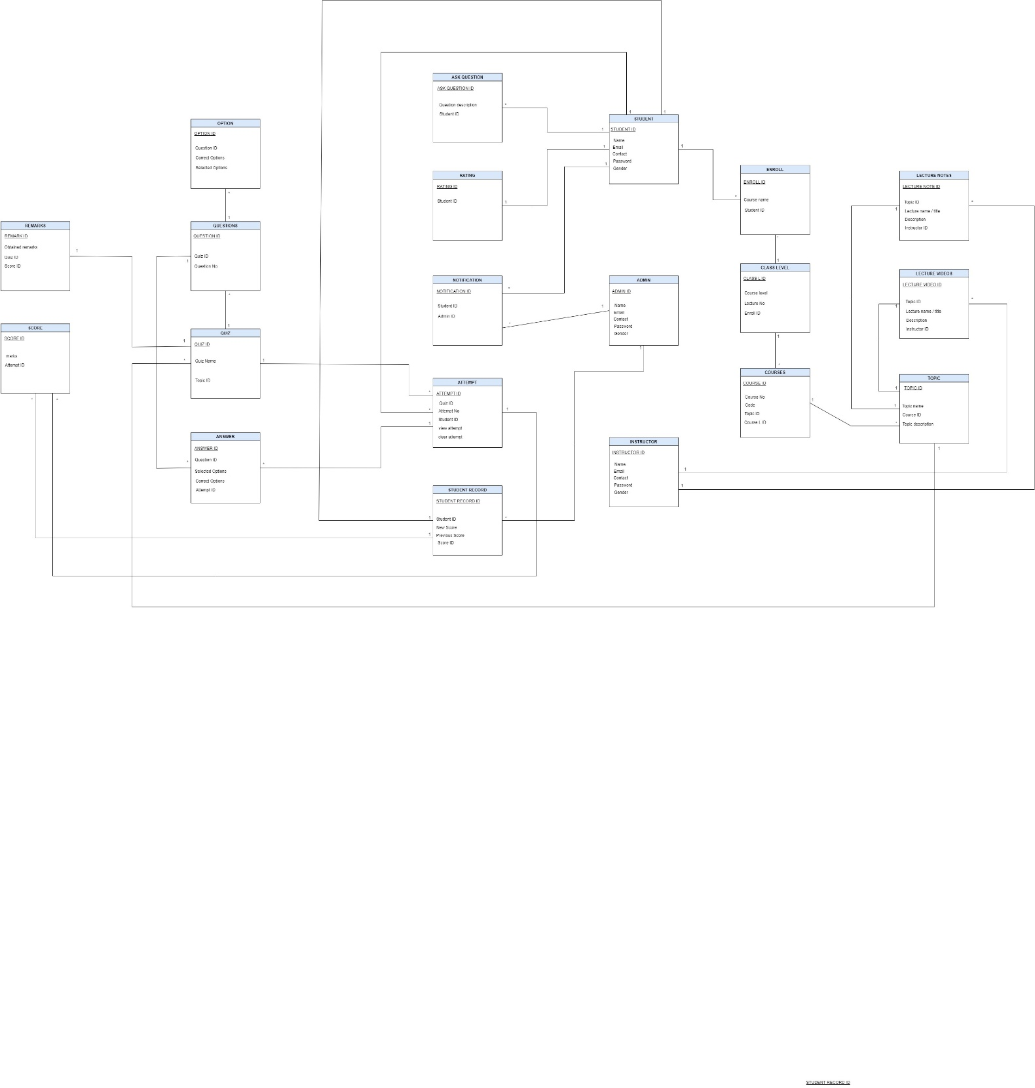

**STATE DIAGRAM**

To model the various states and transitions that the system and its components (such as quizzes, notifications, and user sessions) can undergo, ensuring that the system behaves predictably and handles state changes appropriately.

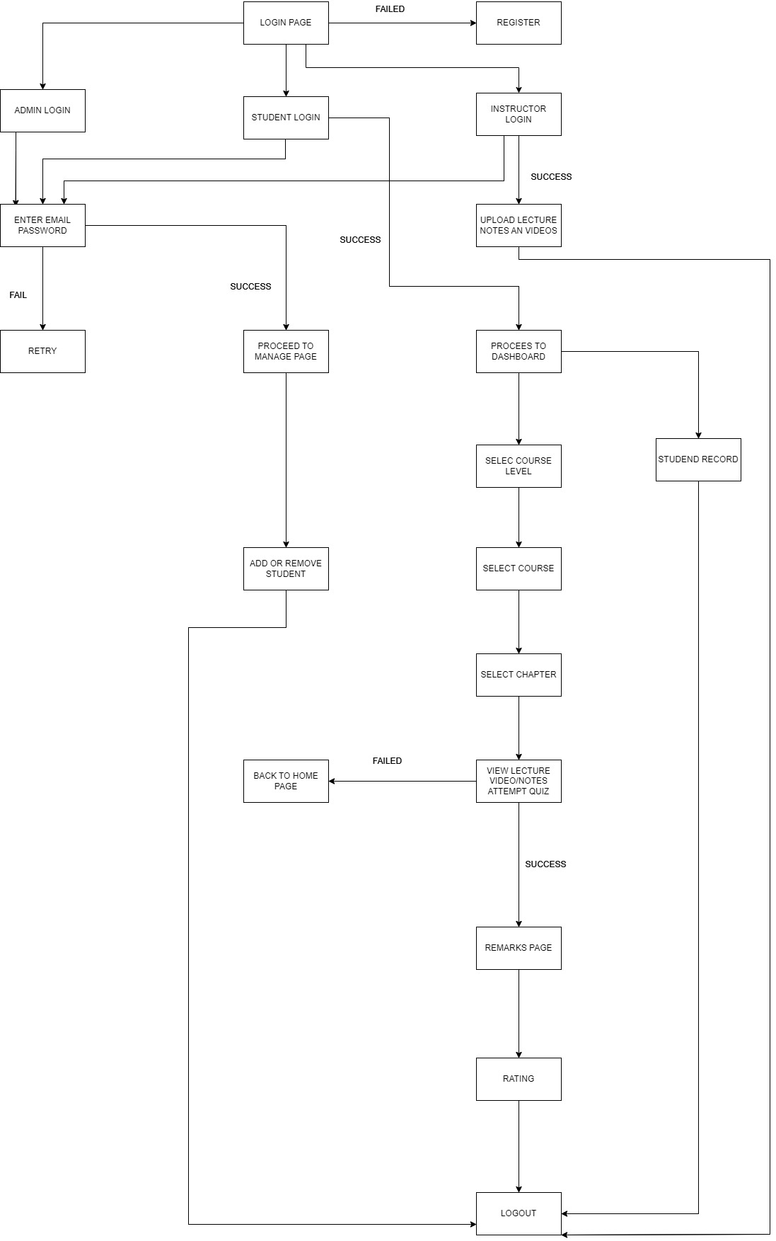

**PROTOTYPE**

Created a visual representation of the user interface and demonstrate core functionalities (like accessing lectures, taking quizzes, using the Chabot), allowing stakeholders to visualize the final product, provide feedback early in the development process, and ensure alignment with user expectation

**STUDENT DASHBOARD AND AUTHENTICATION**

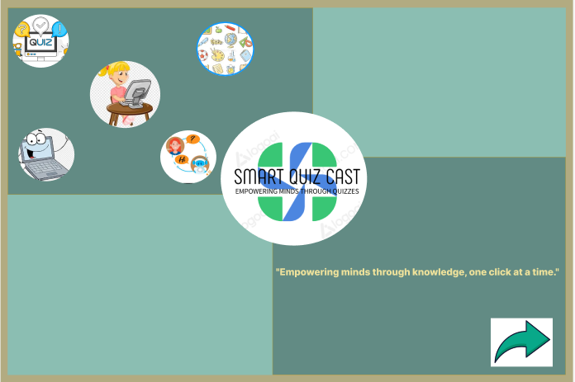



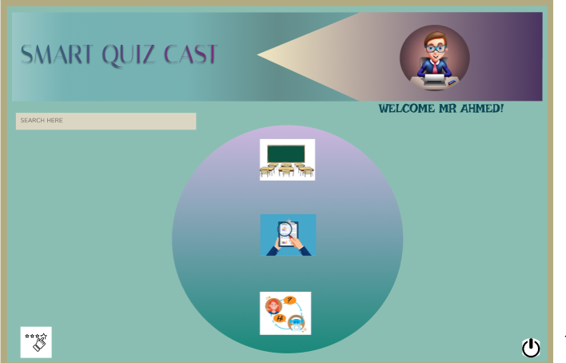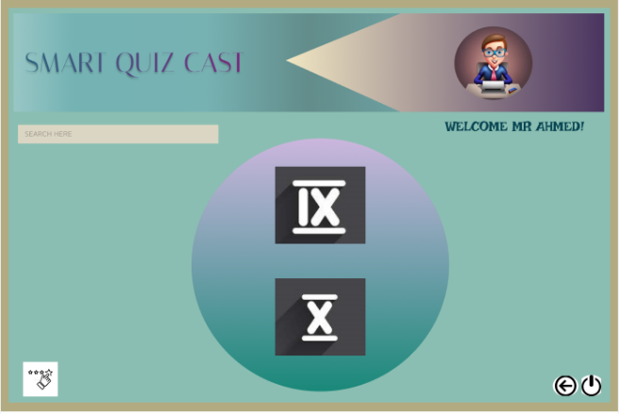

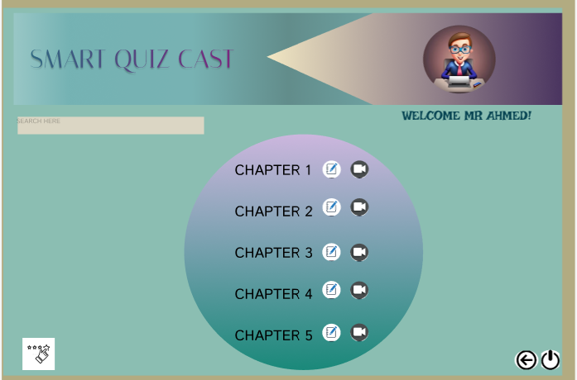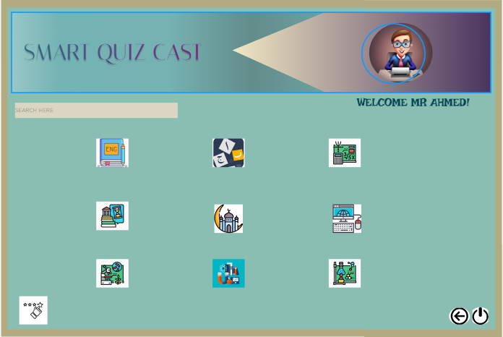  
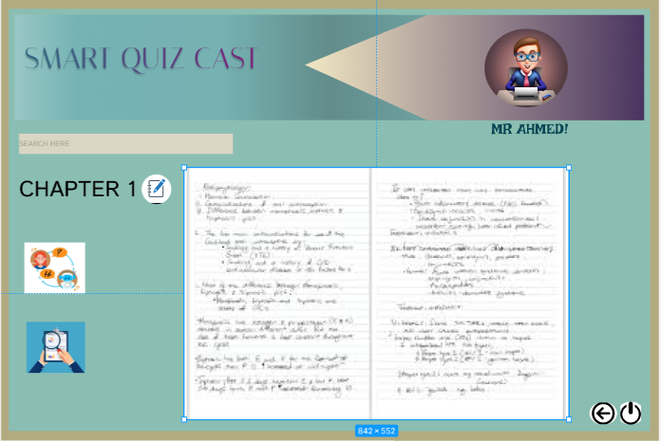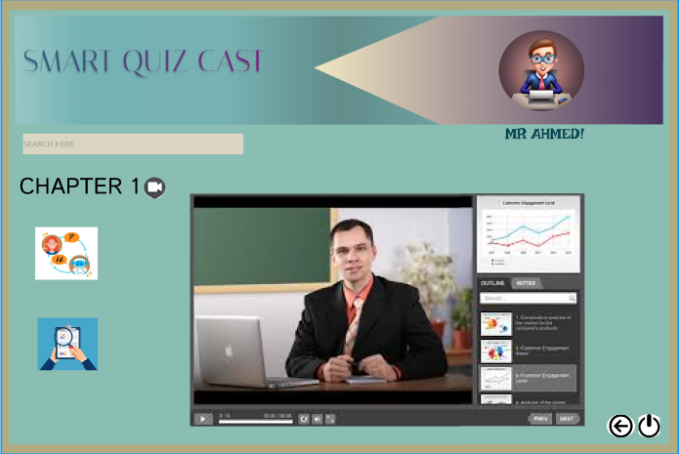

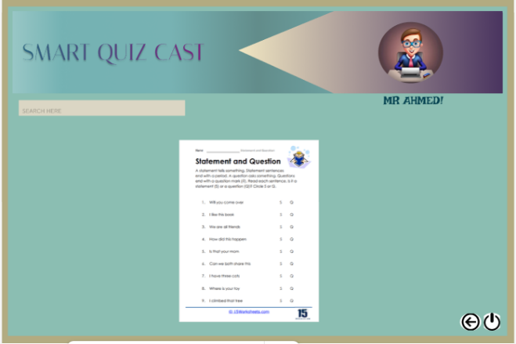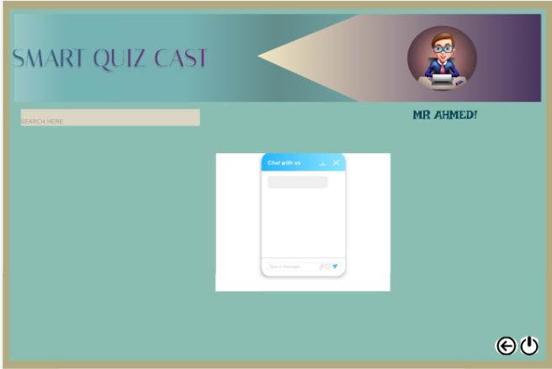

**ADMIN DASHBOARD**

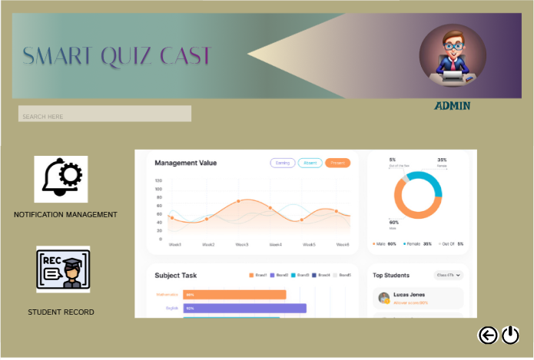

**INSTRUCTOR DASHBOARD**

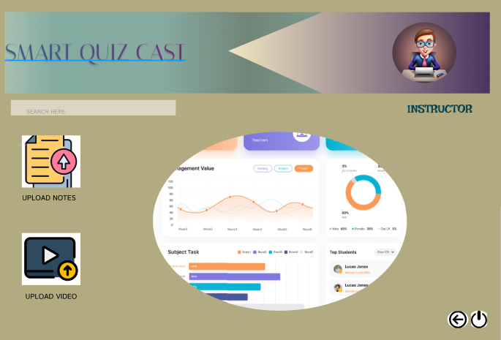

**CONCLUSION:**

This documentation encompasses an Entity-Relationship Diagram (ERD), Use Cases, State Diagrams, and a prototype for our educational website. These elements establish a structured foundation for student interaction, facilitating access to lectures, notes, quizzes, and Chabot services, alongside notifications. The framework outlined here will steer the implementation phase, aimed at enriching learning experiences through interactive and accessible educational resources.

Top of Form

Bottom of Form